**Managing in a Global Economy**

**MASY1-GC 1200 | 100 | Fall 2023 | 9/07/2023 - 12/14/2023 | 3 Credits**

**Modality:** In-Person

**Course Site URL:** https://brightspace.nyu.edu

**General Course Information**

**Name/Title:** Burdin H Hickok, DBA, Adjunct Assistant Professor, Pronouns (dropdown).

**NYU Email:** bh92@nyu.edu

**Class Meeting Schedule:** 9/07/2023 - 12/14/2023 | Thursdays / 6:20 pm - 8:55 pm ET

**Class Location:** TBD

**Office Hours:** I Students can schedule a zoom meeting via Brightspace/ email, or arrange a meeting by appointment before class meetings or as needed after class meetings.

**Description**

This course examines three facets of a modern economy; markets, government, and international trade, and explores the connections among them. The course covers economic principles that power global businesses and organizations today and discusses how modern economies, markets and governments are no longer contained within national boundaries. Upon completion of this course, students learn how a market-based economy operates in today's global environment.

**Prerequisites**

N/A

**Learning Outcomes**

At the conclusion of this course, students will be able to:

* Evaluate stakeholders across different global markets to understand markets, supply chain, and products
* Assess the internal economic drivers that compel organizations to operate and compete globally
* Analyze the impact of cultural differences in implementing a business strategy
* Analyze an enterprise strategy based on managerial roles and responsibilities
* Assess organizational challenges to manage across corporate and national boundaries in order to identify strategic opportunities

**Communication Methods**

Be sure to turn on your [NYU Brightspace notifications](https://www.nyu.edu/servicelink/KB0018507) and frequently check the “Announcements” section of the course site. This will be the primary method I use to communicate information critical to your success in the course. To contact me, send me an email. I will respond a quickly as I can usually within 24hrs.

Credit students must use their NYU email to communicate. Non-degree students do not have NYU email addresses. Brightspace course mail supports student privacy and FERPA guidelines. The instructor will use the NYU email address to communicate with students. All email inquiries will be answered within 24 hours.

**Structure | Method | Modality**

This course is In-person and will meet once a week on Thursday. Brightspace is the learning management system we will use. Students are expected to check email and/or Brightspace for announcements concerning assignments, class changes or cancellations, and other important information. The course is case analysis based where students read cases before class and be prepared to discuss at length and in detail.

Active learning experiences and small group projects are key components of the course. Assignments and exams will be based on course materials (e.g., readings, videos), lectures, and class discussions. Assessment will be based upon a mid-term and final exam involving case studies, and class participation.

**Expectations**

Learning Environment

You play an important role in creating and sustaining an intellectually rigorous and inclusive classroom culture. Respectful engagement, diverse thinking, and our lived experiences are central to this course and enrich our learning community. As graduate students, you are expected to conduct yourselves in a professional manner and engage and collaborate with your classmates. SPS classrooms are diverse and include students who range in age, culture, learning styles, and levels of professional experience. To maintain an inclusive environment that ensures all students can equally participate with and learn from each other, as well as receive feedback and instruction from faculty during group discussions in the classroom, all course-based discussions and group projects should occur in a language that is shared among all participants.

Participation

It is required that students attend class and be part of the group case studies that will take place in class. Each student is expected to contribute to the in-class discussions around case studies. Each session will require students to read the case studies individually prior to that session. Each student is required to contribute his or her own ideas, opinions and feedback during group discussions about the case study. To better facilitate discussion and student engagement the class will be divided into groups for case analysis. Please note that these groups will not remain static and will change during the semester.

You are integral to the learning experience in this class. Be prepared to actively contribute to class activities, group discussions, and work outside of class.

Assignments and Deadlines

All students must complete all course assignments. You should come to each class fully prepared, having read the assigned readings and completed the assignments (s), and actively engage in class discussions. See course outline for regular cases and reading to be completed before class. The number of the assignments and their due dates are on the course outline section of the syllabus. All assignments must be uploaded to the folder on Brightspace labeled "Assignments." Each assignment sub-folder will include the detailed assignment description and grading criteria/rubric.

Missed assignments will lower the student’s grade based on the percentage of the grade allocable to it. Late assignments are permitted only with advance notice to, and permission from, the instructor, and the grade will be lowered according to how late the assignment is submitted.

dd here

Course Technology Use

We will utilize multiple technologies to achieve the course goals. I expect you to use technology in ways that enhance the learning environment for all students. All class sessions require use of Zoom.All class sessions require use of technology (e.g., laptop, computer lab) for learning purposes. In class, the use of computers is acceptable for note taking and access to cases.

Feedback and Viewing Grades

I will provide timely meaningful feedback on all your work via our course site in NYU Brightspace. You can access your grades on the course site Gradebook.

Attendance

Students are expected to attend all on-line class sessions. Excused absences are granted in cases of documented serious illness, family emergency, religious observance, or civic obligation. In the case of religious observance or civic obligation, this should be reported in advance. Unexcused absences from sessions may have a negative impact on a student’s final grade. Students are responsible for assignments given during any absence.

If for some reason (excused absence) you will not be in class, you must notify the instructor prior to the scheduled session if you will not be attending and the reason.

Each unexcused absence or being late may result in a student’s grade being lowered by a fraction of a grade. A student who has three unexcused absences may earn a Fail grade.

Students who join the course during add/drop are responsible for ensuring that they identify what assignments and preparatory work they have missed and complete and submit those per the syllabus.

Refer to the [SPS Policies and Procedures page](https://www.sps.nyu.edu/homepage/student-experience/policies-and-procedures.html) for additional information about attendance.

**Textbooks and Course Materials**

Students can purchase through the NYU Bookstore, or buy used online or rent if possible. HBS course pack is available directly through the HBS link: <https://hbsp.harvard.edu/import/1077219>

**Case Analysis Coach: Harvard Business Publishing**: NYU Bookstore will provide access upon purchase.If this is the first course that incorporates case study method I would strongly suggest that you purchase and read this tutorial. It will help you in this class and future classes where case studies are used.

**Required: Transnational Management: Text, Cases, and Readings in Cross-Border Management**, Bartlett, Christopher A., Beamish, Paul W., 8th Edition, Cambridge University Press, ’18 ISBN: 978-1108422437

**Case Studies not in Text will be announced in Brightspace and available online through HBS Publishing at this link:** [**https://hbsp.harvard.edu/import/1077219**](https://hbsp.harvard.edu/import/1077219)

**\* Important note* Best to not purchase the course pack in its entirety at the beginning of the course.** Because of the rigidity of the HBS website, I have intentionally labeled all materials in the course pack as “optional”. This allows for greater flexibility to add and/or subtract materials during the course. It is best if you access the specific reading materials when you need to prepare for class

**Required*:* Global Political Economy; Robert Gilpin, Princeton Paperbacks, ’01** (We will only read 4 chapters in this book, however, it is cheaper for you to buy a used copy than to have the individual chapters included in a course pack, additionally there is supplementary reading & it is a highly regarded survey book of current thought on international economics and politics) **ISBN:** 069108677X / **ISBN13:** 9780691086774*.*

**Grading | Assessment**

Your grade in this course is based on your performance on multiple activities and assignments. Since all graded assignments are related directly to course objectives and learning outcomes, failure to complete any assignment will result in an unsatisfactory course grade. All written assignments are to be completed using APA format and must be typed and double-spaced. Grammar, punctuation, and spelling will be considered in grading. Please carefully proof-read your written assignments before submitting them for a grade. I will update the grades on the course site each time a grading session has been completed— typically three (3) days following the completion of an activity.

**DESCRIPTION** **PERCENTAGE**

Participation 20%

Midterm Project 35%

Final Exam 45%

__________________ ______

TOTAL POSSIBLE 100%

See the [“Grades” section of Academic Policies](https://www.sps.nyu.edu/homepage/student-experience/policies-and-procedures.html#Graduate1) for the complete grading policy, including the letter grade conversion, and the criteria for a grade of incomplete, taking a course on a pass/fail basis, and withdrawing from a course.

**Course Outline**

**Start/End Dates:** 09/07/2023 - 12/14/2023 / Thursdays

**Time:** 06:20pm -- 08:55pm

**No Class Date(s):** No class date: Thursday, 11/23/23, Thanksgiving Recess

**Special Notes:** N/A

All assignments and exams are to be submitted through Brightspace

**Class 1 – September 7: Assignments – To be read before class**

**Case Analysis Coach**; Tutorial;

**Global Political Economy**: Chapters 5, 6, 8, & 11

**Transnational Management:** Chapter 1; Expanding Abroad: Motivations, Means and Mentalities, pp. 1-16

**Case** **1-3:** MABE: Learning to be a Multinational pp. 47

**Following brief introductions, Course Overview, and Syllabus Review** we will discuss background economic theory that helps put our course into a global context. Gilpin’s Global Political Economy provides a valuable overview of current thought on global macroeconomics and the world in which MNEs operate. How can recent work in macroeconomic theory help managers of global enterprises? What is our role as managers in a global firm? What is the role of corporations in general? Expanding to new markets in new countries entail a great deal of foresight, assumptions and hard work for success.

**Objective and Outcomes –**

* Understand what you may have learned in school is only part of the picture. In with the “new” out with the “old?” Failures of Neoclassical economics and new theories that better describe a dynamic global economy
* Understand and apply key roles of a corporation and shareholder value may dictate expansion (growth) internationally? Why Shareholder value?
* Understand and apply the Motivations, Means and Mentalities for international expansion

Discussion points that should guide your reading and understanding of this case

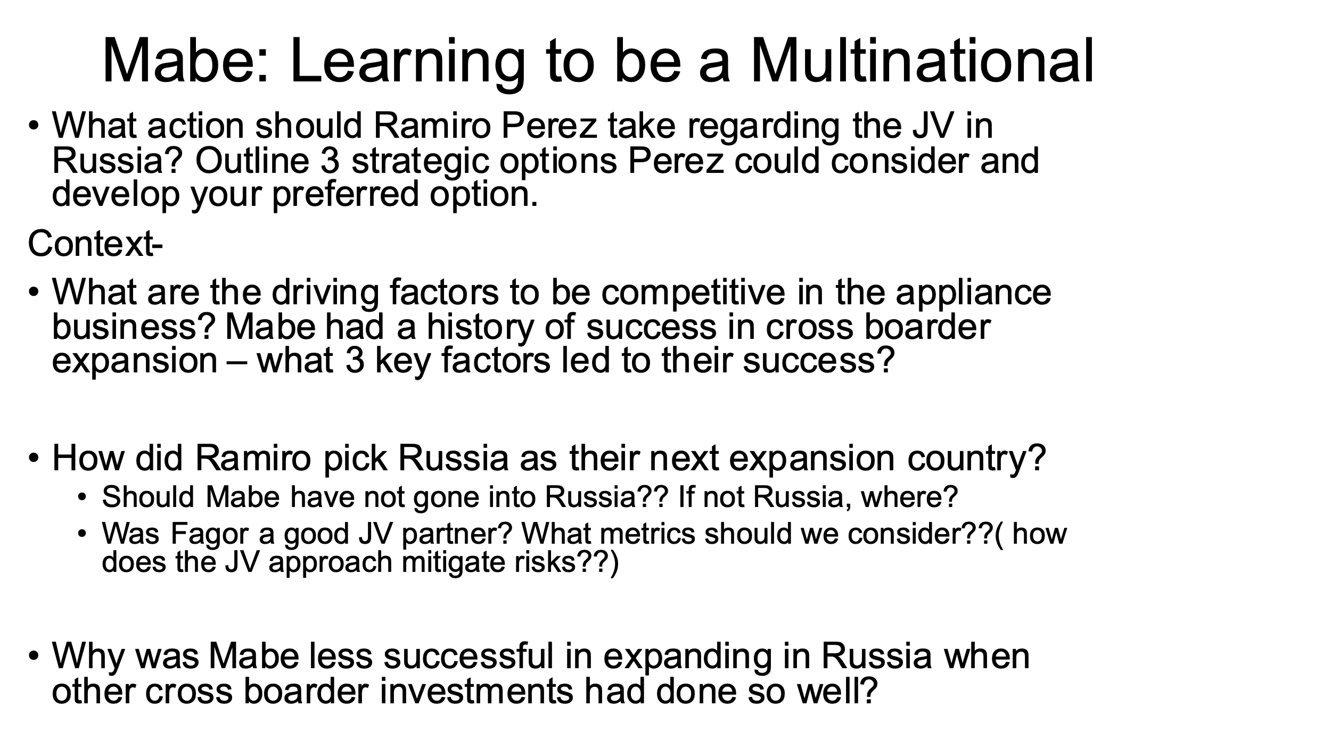

Class 2 – September 14: Assignments – To be read before class: Transnational Chapter 2;

* **Case 2-4:** Mahindra & Mahindra in South Africa; pp. 134
* **Case:** Acer, Inc.; Taiwan’s Rampaging Dragon, HBS Course pack

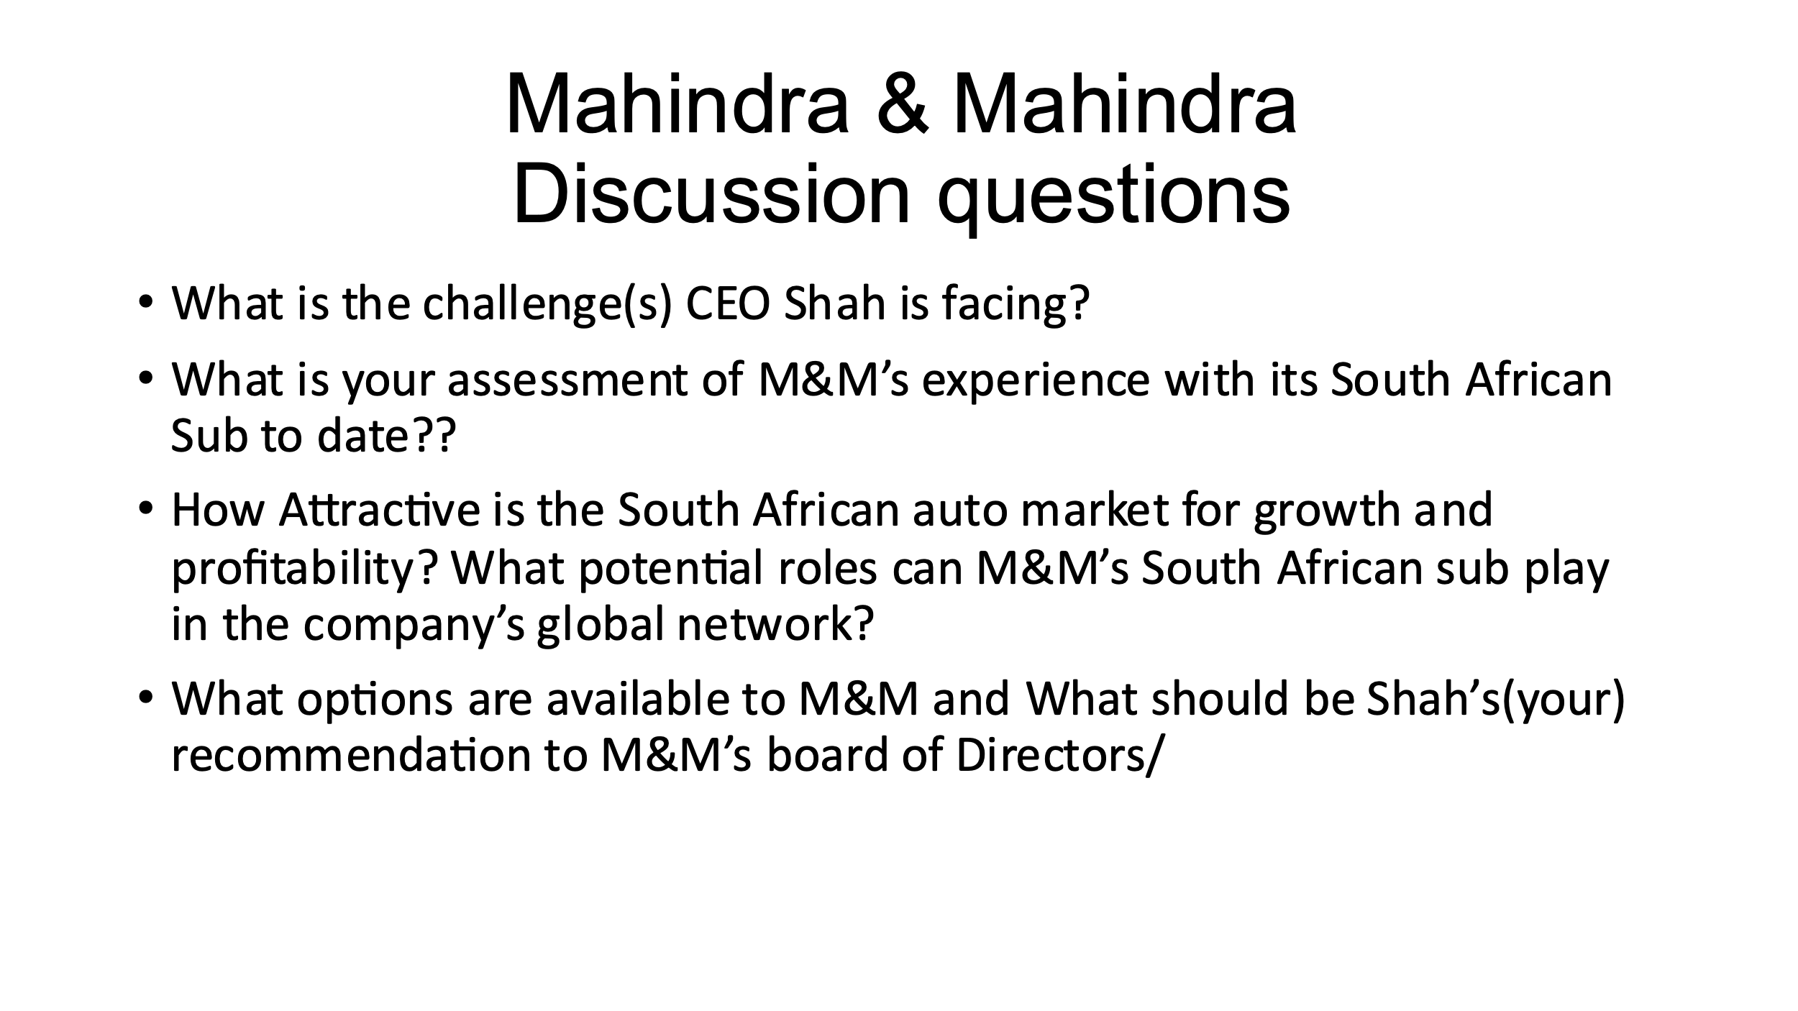

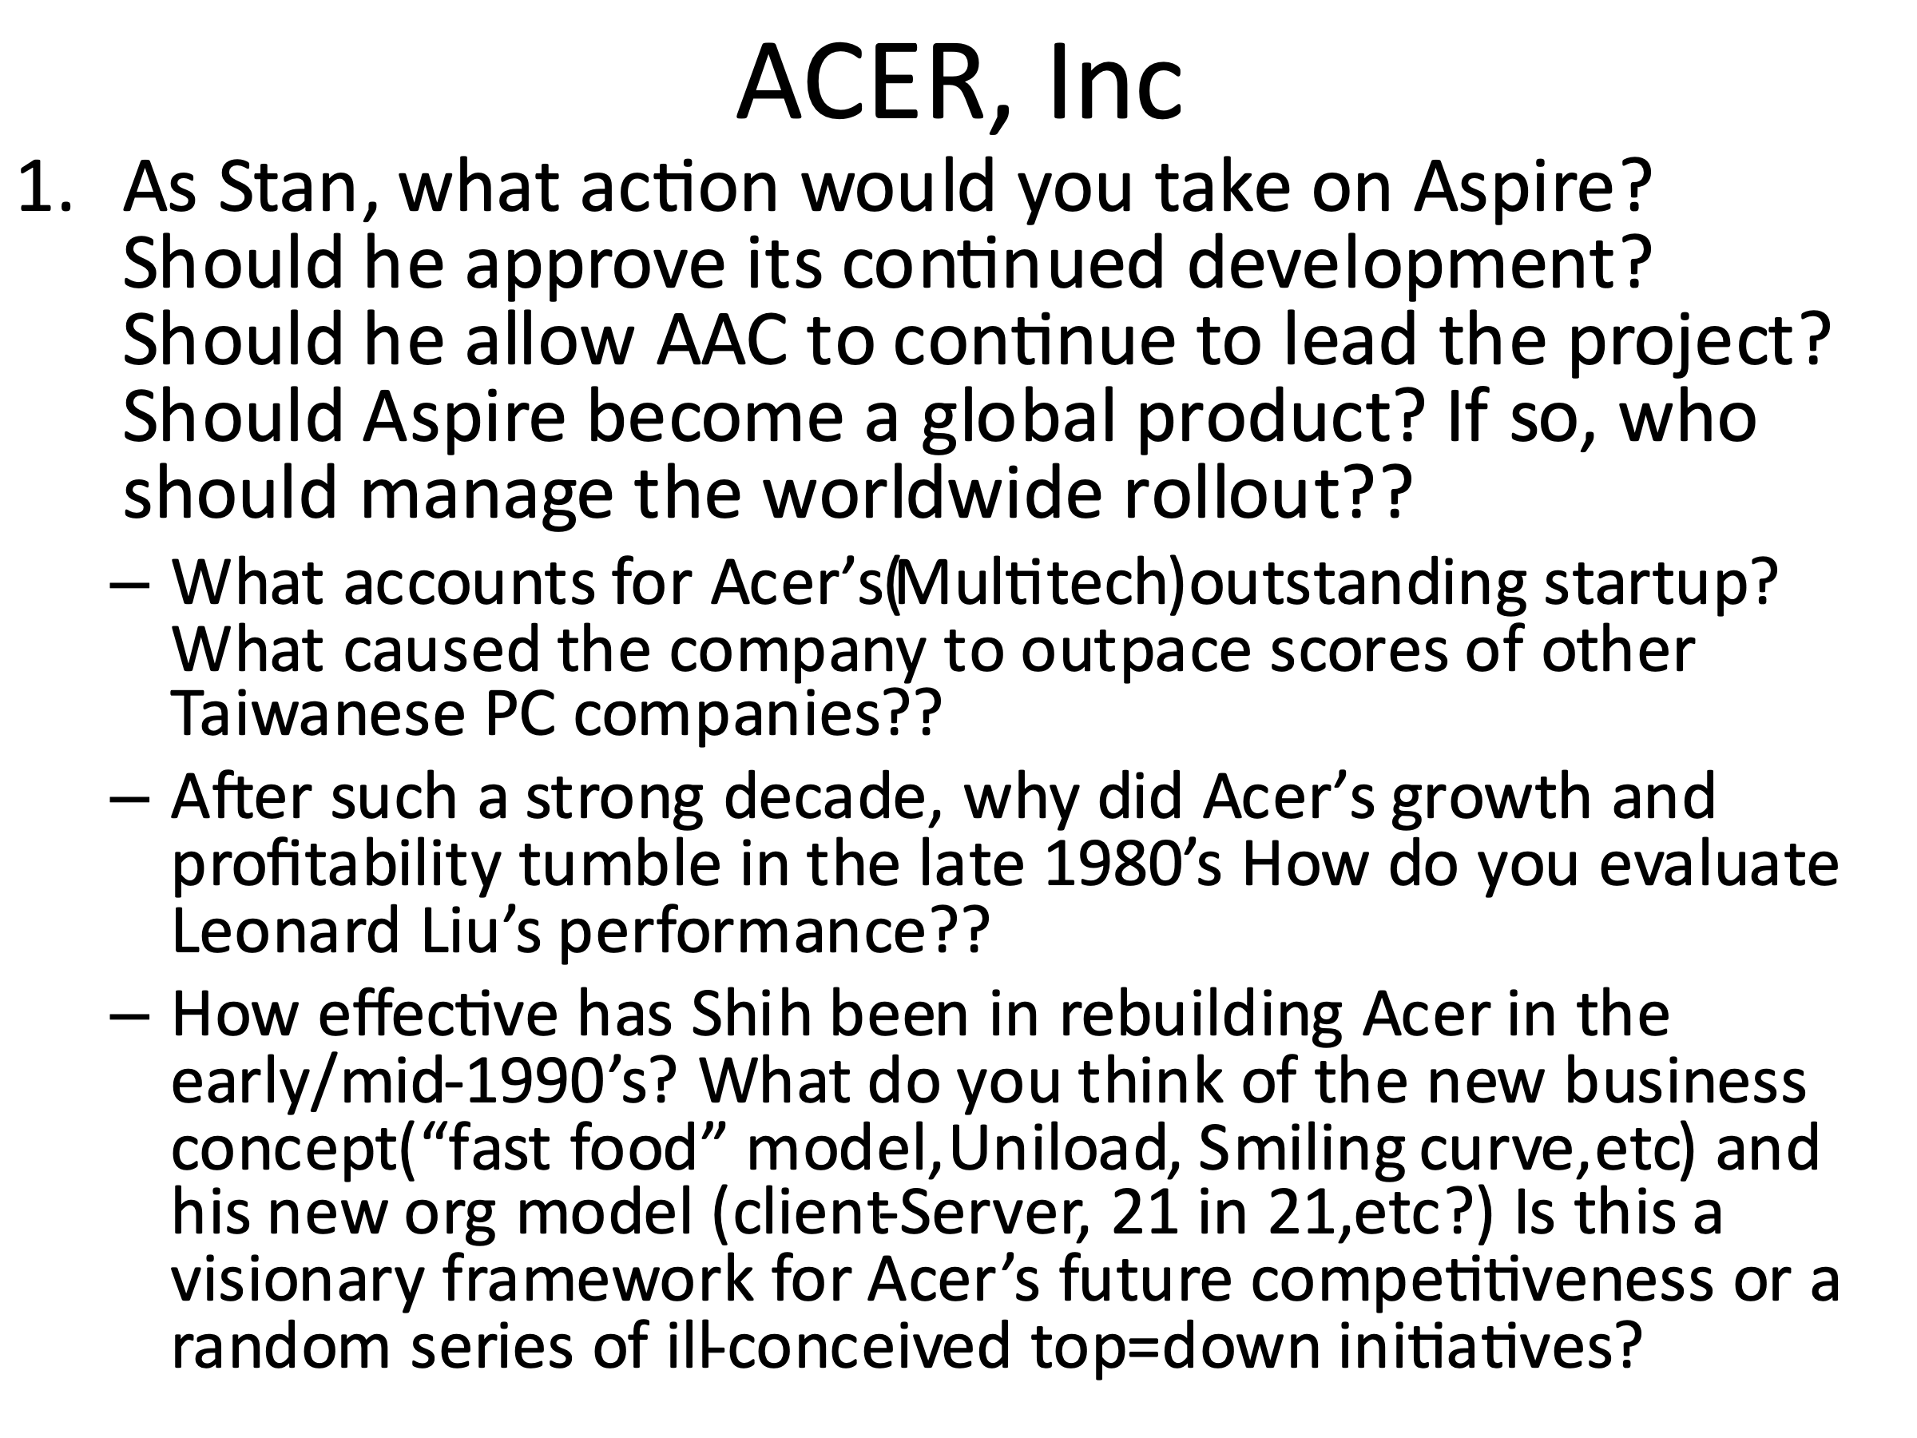

**Class 3 – September 21: Understanding the International Context – Doing business internationally and understanding the conflicting environmental forces**

**Assignments – To be read before class**

* Distance Still Matters (CAGE), HBS Course pack;
* **Case 2-2 Text:** MTN and the Nigerian Fine, pp. 104

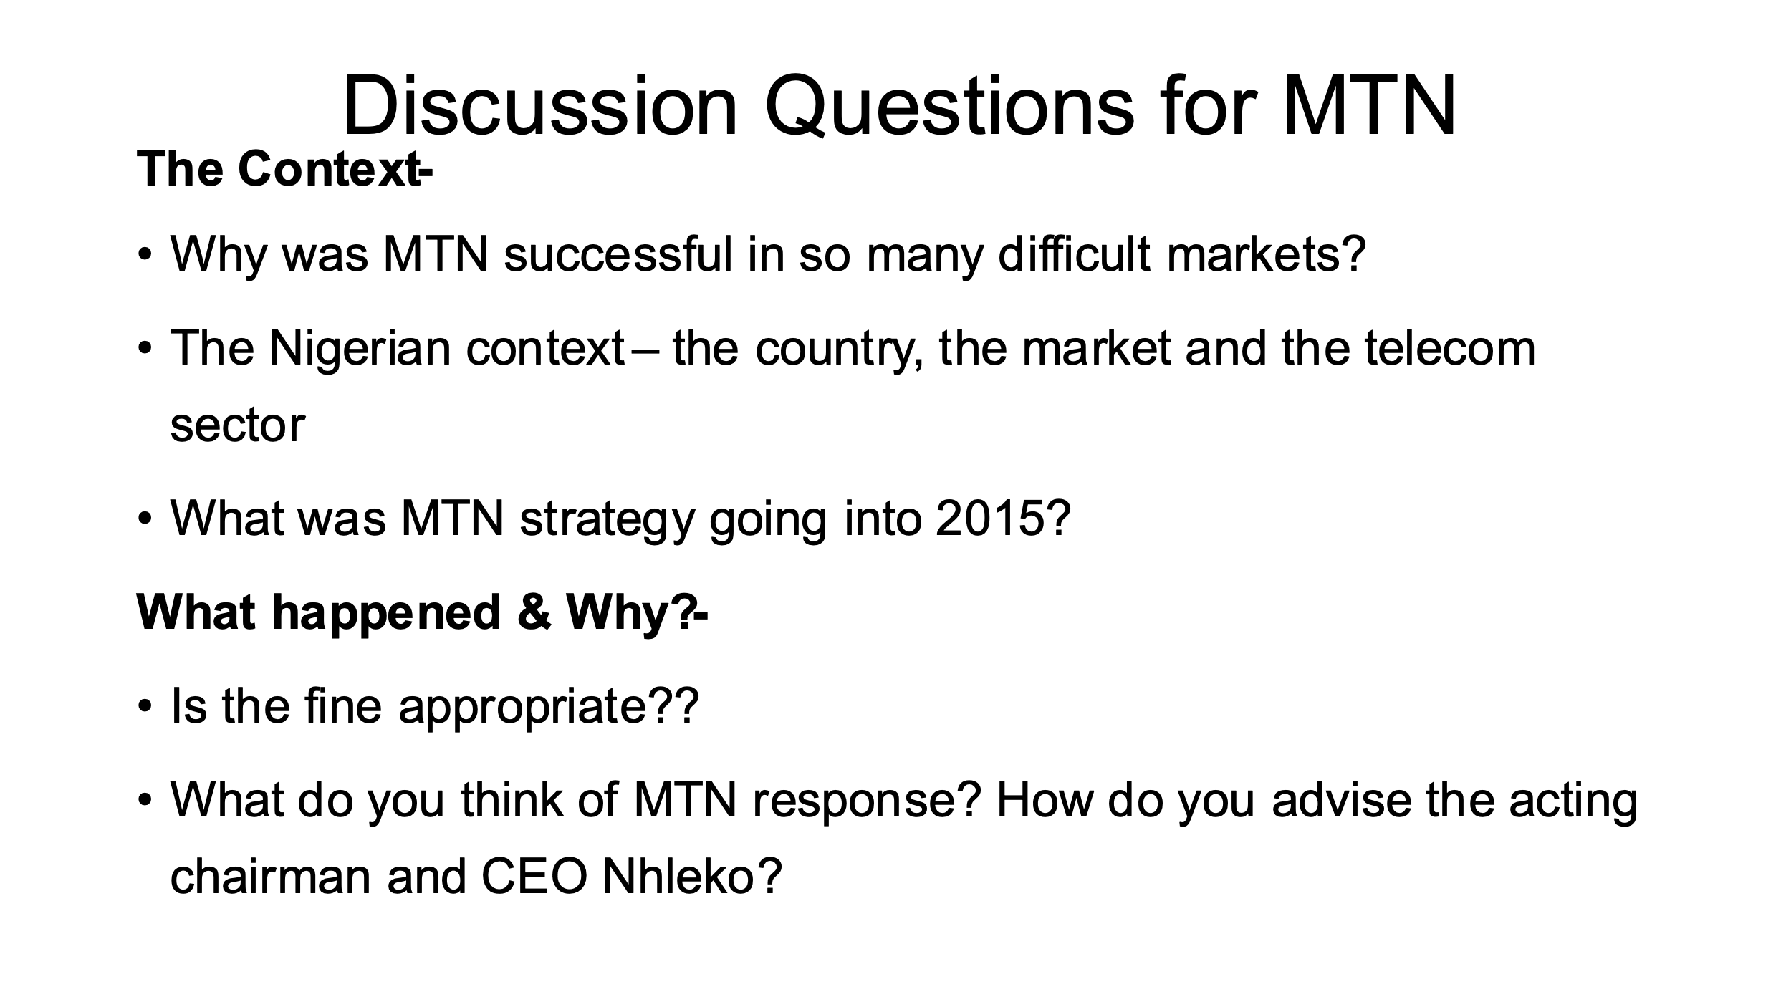

* **Case:** The Globalization of CEMEX, HBS Course pack

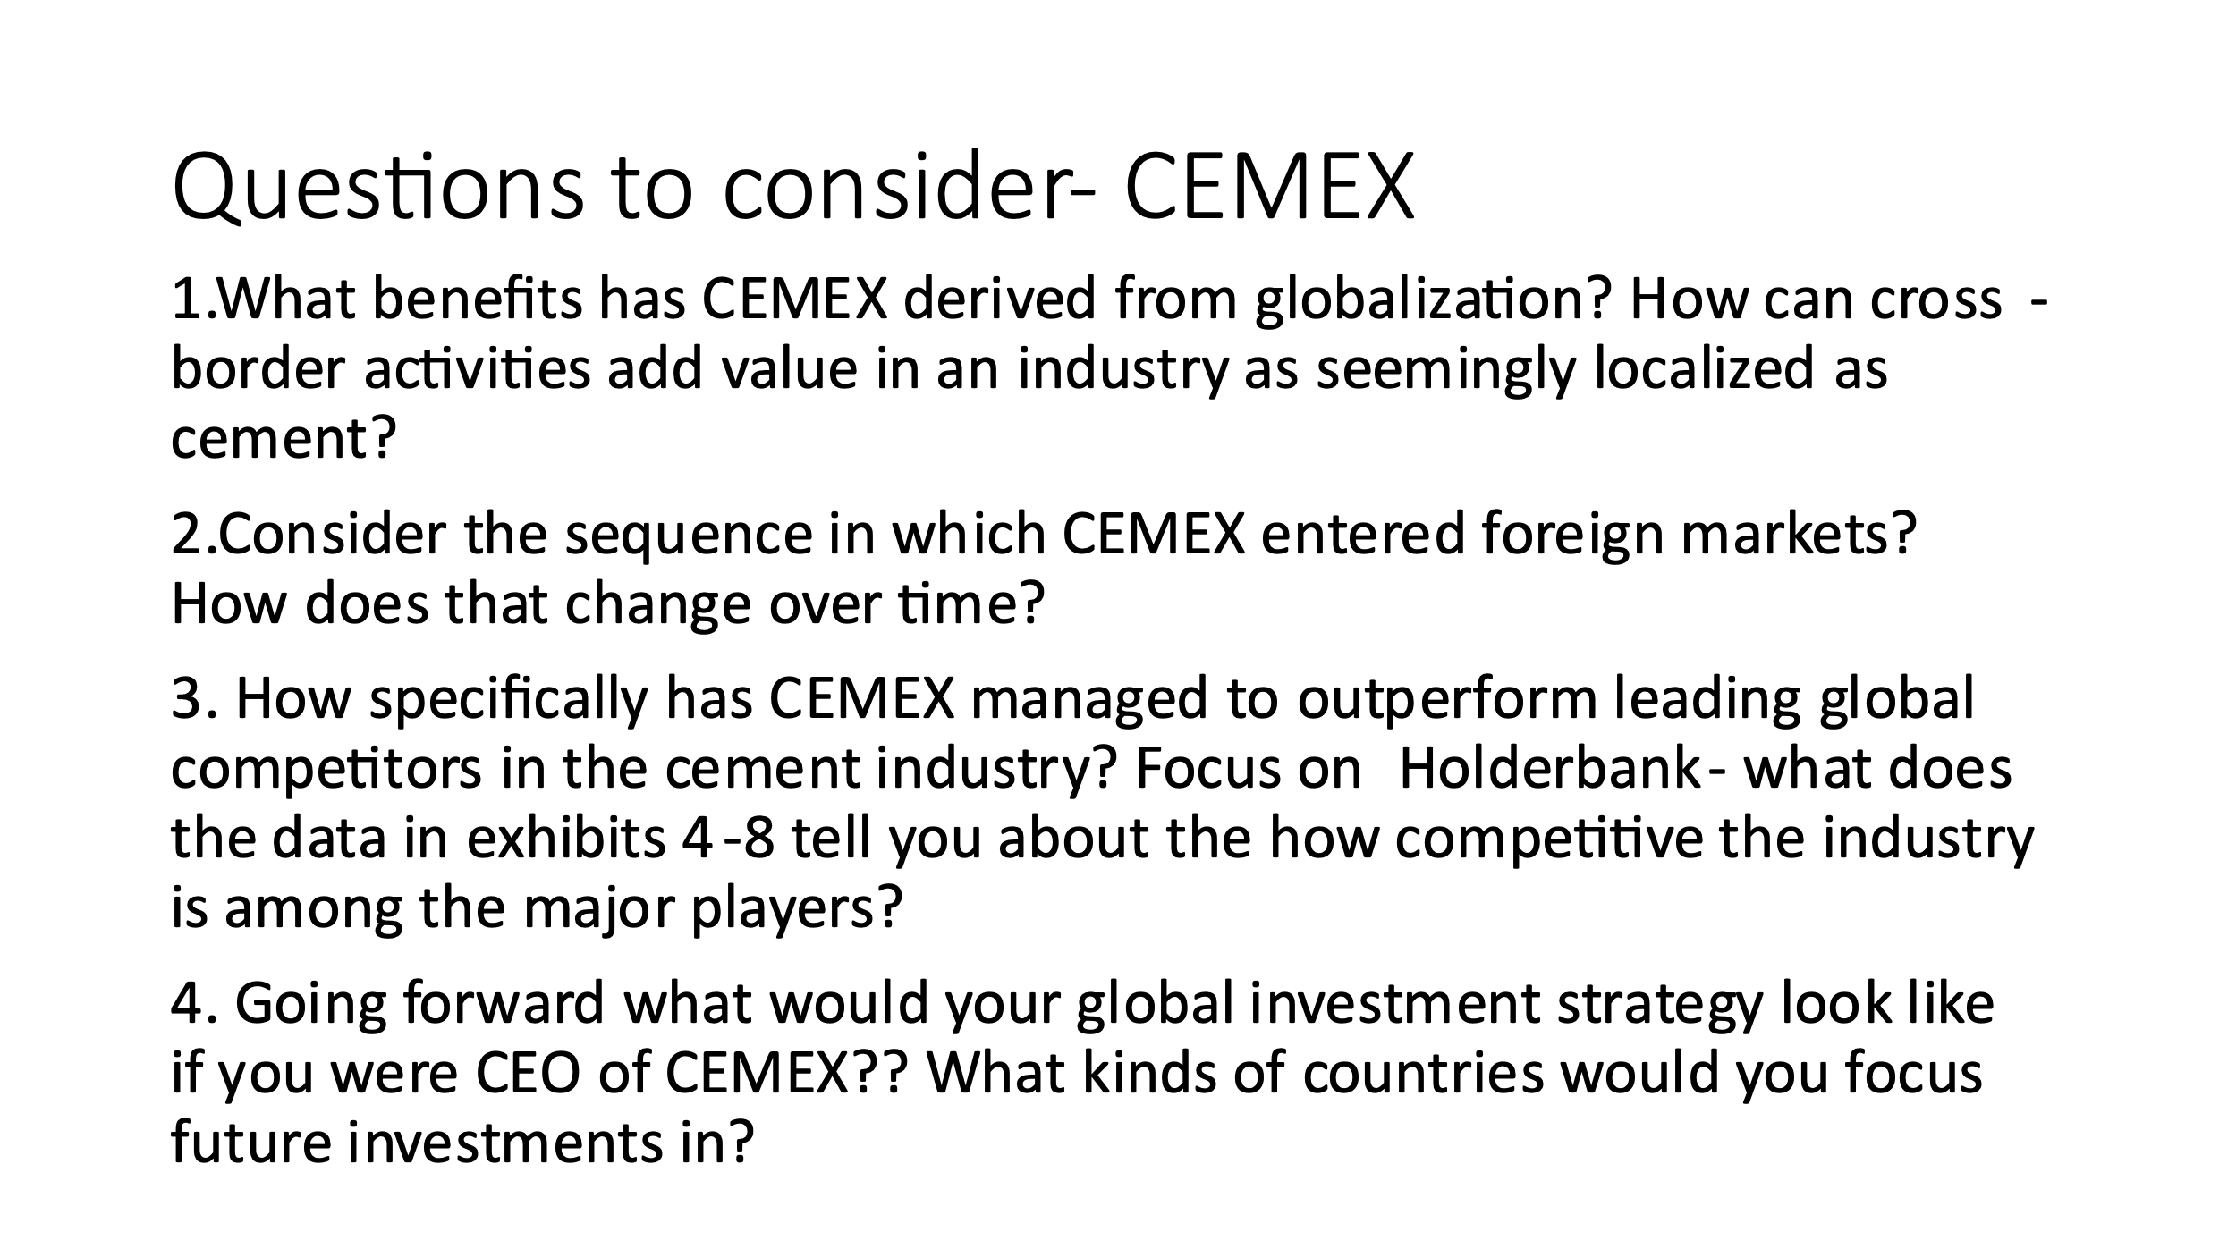

**Class 4 – September 28: Assignments – To be read before class**

* **Case:** Intel: Strategic Decisions in Locating a New Assembly and Test Plant (A) – **HBS Course pack**

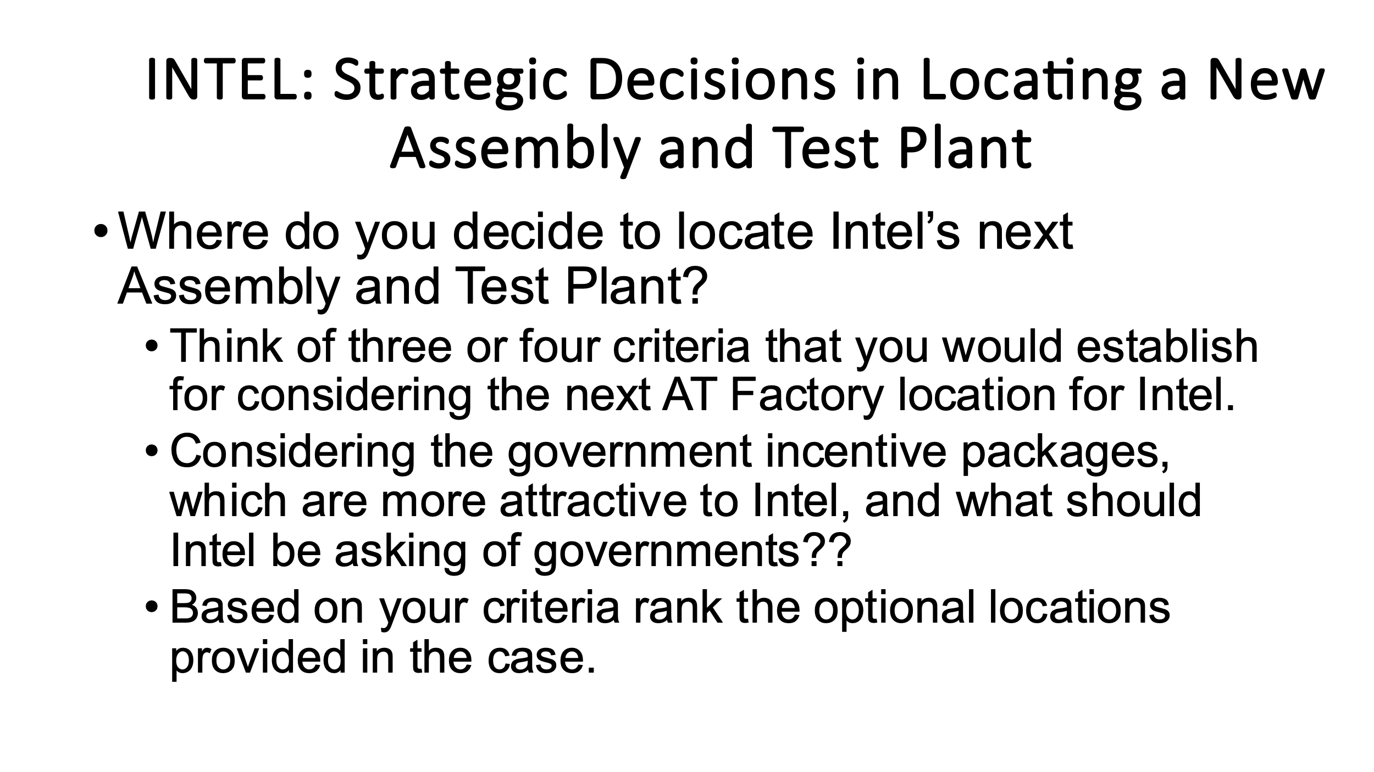

* **Case 4-2 Text:** Lundbeck Korea: Managing an International Growth Engine, page 245

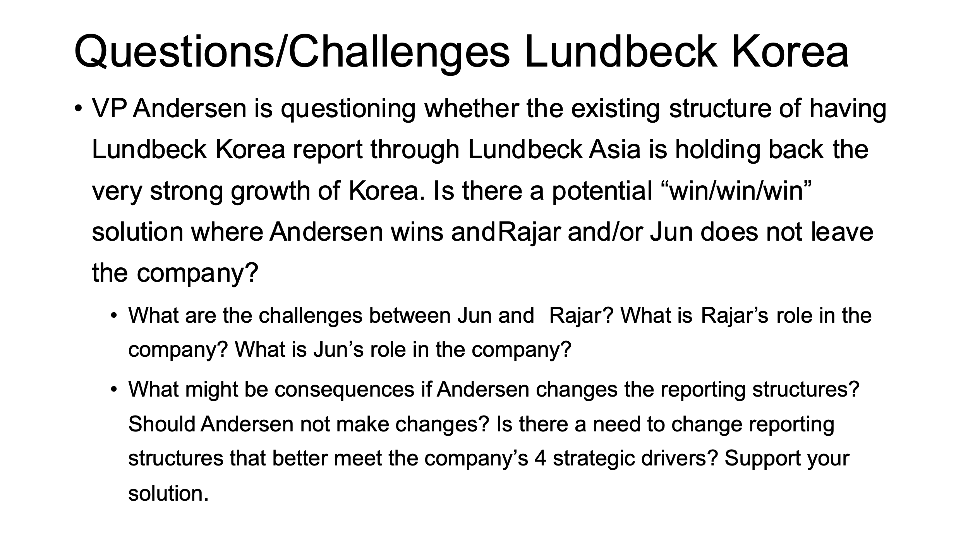

**Class 5 – October 5: Developing Transnational Strategies – Developing and understanding strategies for Global Companies**

**Assignments – To be read before class**

**Transnational Management:** Read Chapter 3, Developing Transnational Strategies; Building Layers of Competitive Advantage, pp. 208-222

Lecture: Hofstede’s Cultural Score Card

* **Case:**
* **Case:** Arla Foods and the Cartoon Crisis - - Ivy Publishing course pack-<https://www.iveycases.com/Coursepack.aspx?id=30489> ( you will need to register to access the case.)

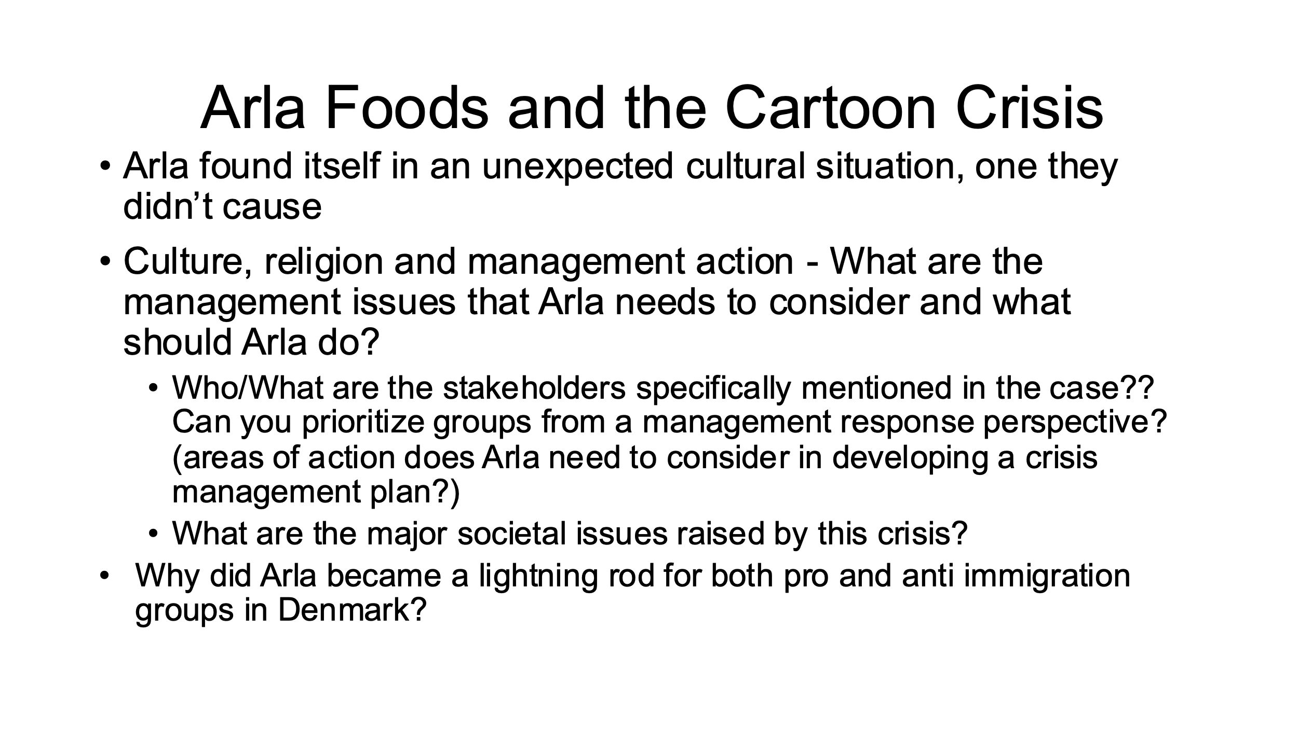

* Case 7-3: “ Silvio Napoli at Schindler India” page 452

**Class 6 – October 12: Midterm – Case analysis – TBA**

This exam will follow a similar discipline as previous cases we have discussed in class. A case will be assigned to be read before class. During class time you will be given several themes of analysis and questions to be answered through a written analysis and requiring supporting arguments.

**Class 7 – October 19: Transnational Management chapter 4: Developing a Transnational Organization, Managing Integration, Responsiveness and Flexibility - How do we develop a transnational organization? What are the integrations and is it necessary to be responsive and flexible when developing this organization?**

**Assignments – To be read before class**

* **Read Chapter 4:** Developing a Transnational Organization, pp. 215
* **Case:** Global Diversity and Inclusion at Royal Dutch Shell (A)– **HBS Course Pack**

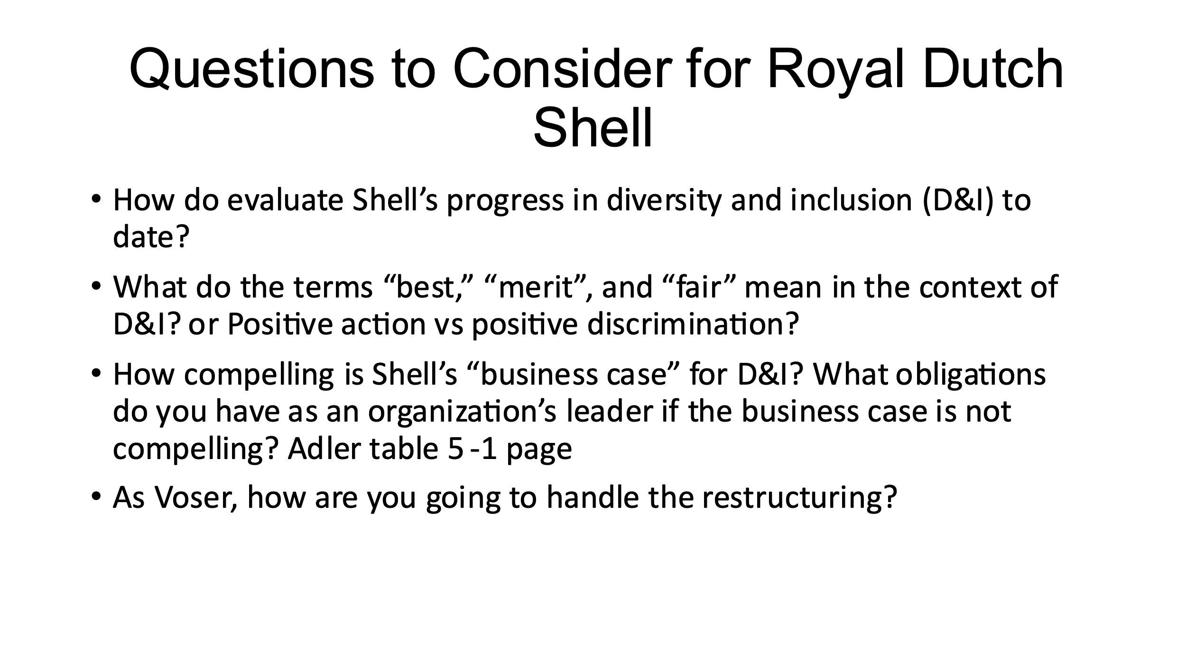

* **Case:** Global Leadership in a Dynamic and Evolving Region: Molinas@ The Coca-Cola Company (A) only – **HBS Course Pack**

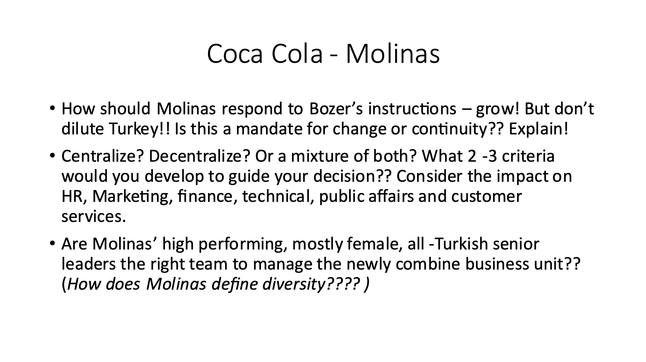

**Class 8 – October 26: Assignments – To be read before class**

* **Reading** Matrix Management: Not a Structure, A Frame of Mind, **HBS Course pack**
* **Case 4-1 Text:** Kent Chemical: Organizing for International Growthp. 235

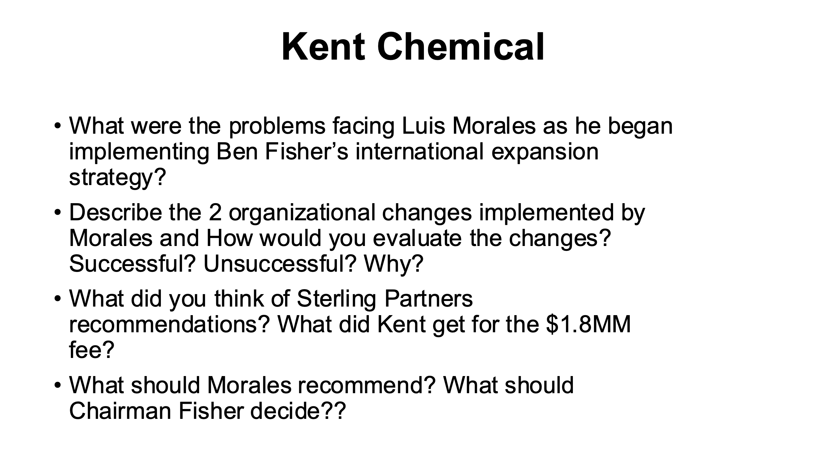

* **Case:** Managing a Global Team: Greg James at Sun Microsystems, **HBS Course pack**

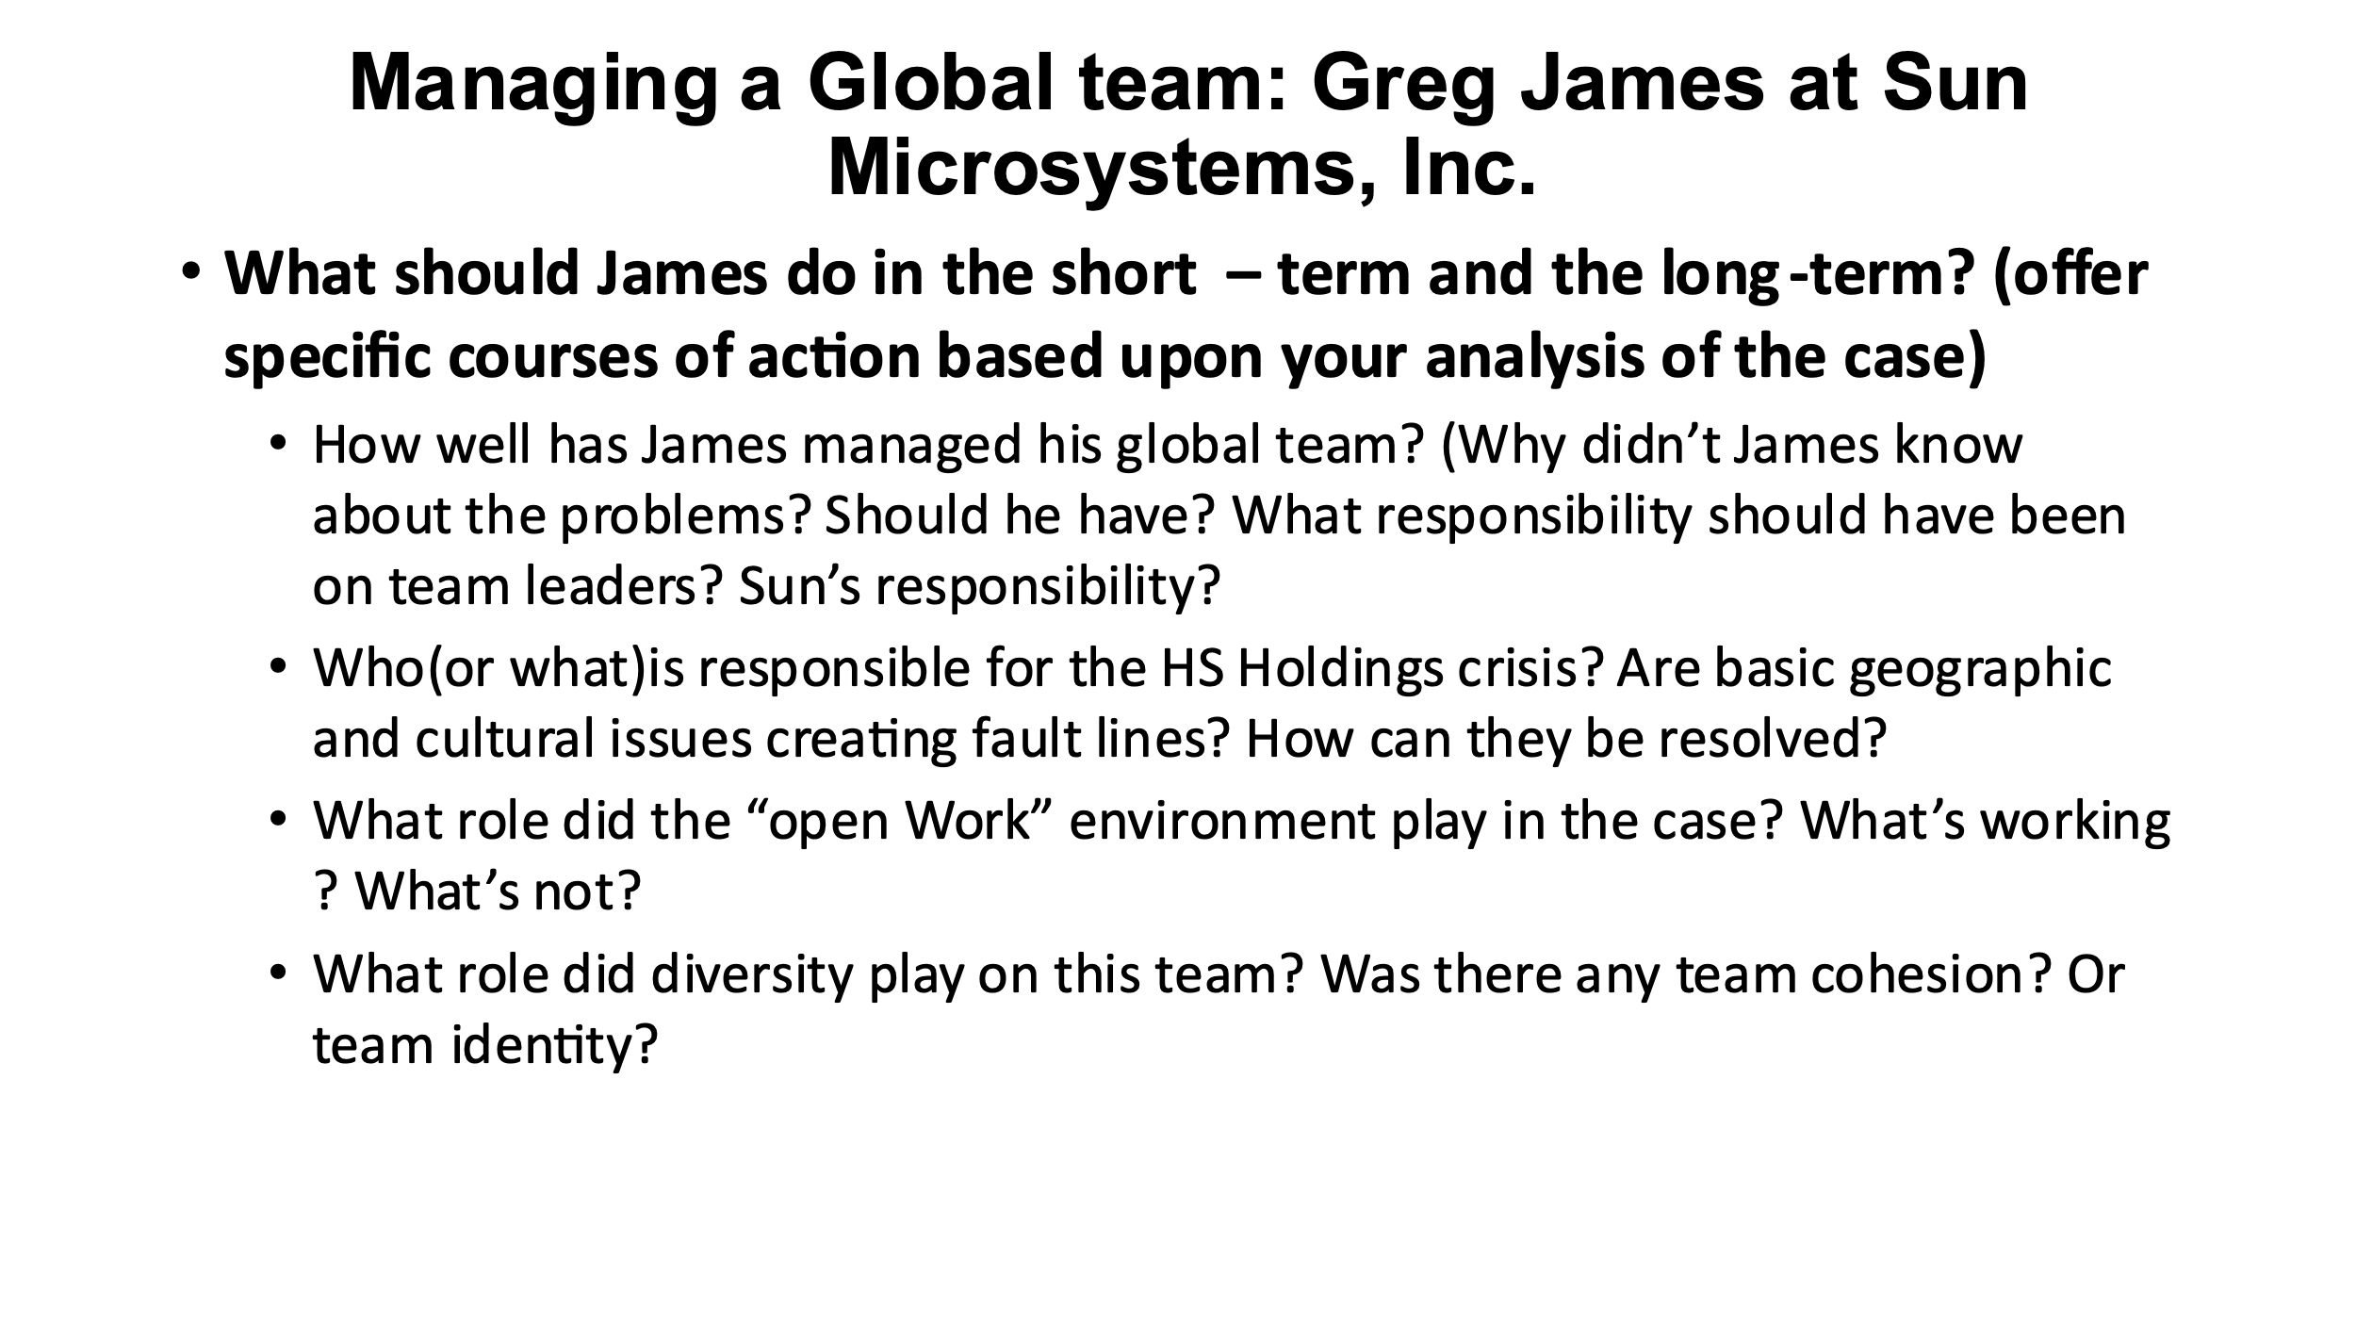

Class 9 – November 2: Worldwide Innovation and Cross-Border Collaboration - How do we create worldwide innovations and whom do we involve? Understand cross-border knowledge management

**Assignments – To be read before class**

* **Read Chapter 5:** Creating Worldwide Innovation and Learning, pp. 293
* **Case 5-2 Text:** Applied Research Technologies, Inc.: Global Innovation’s Challenges, pp. 324

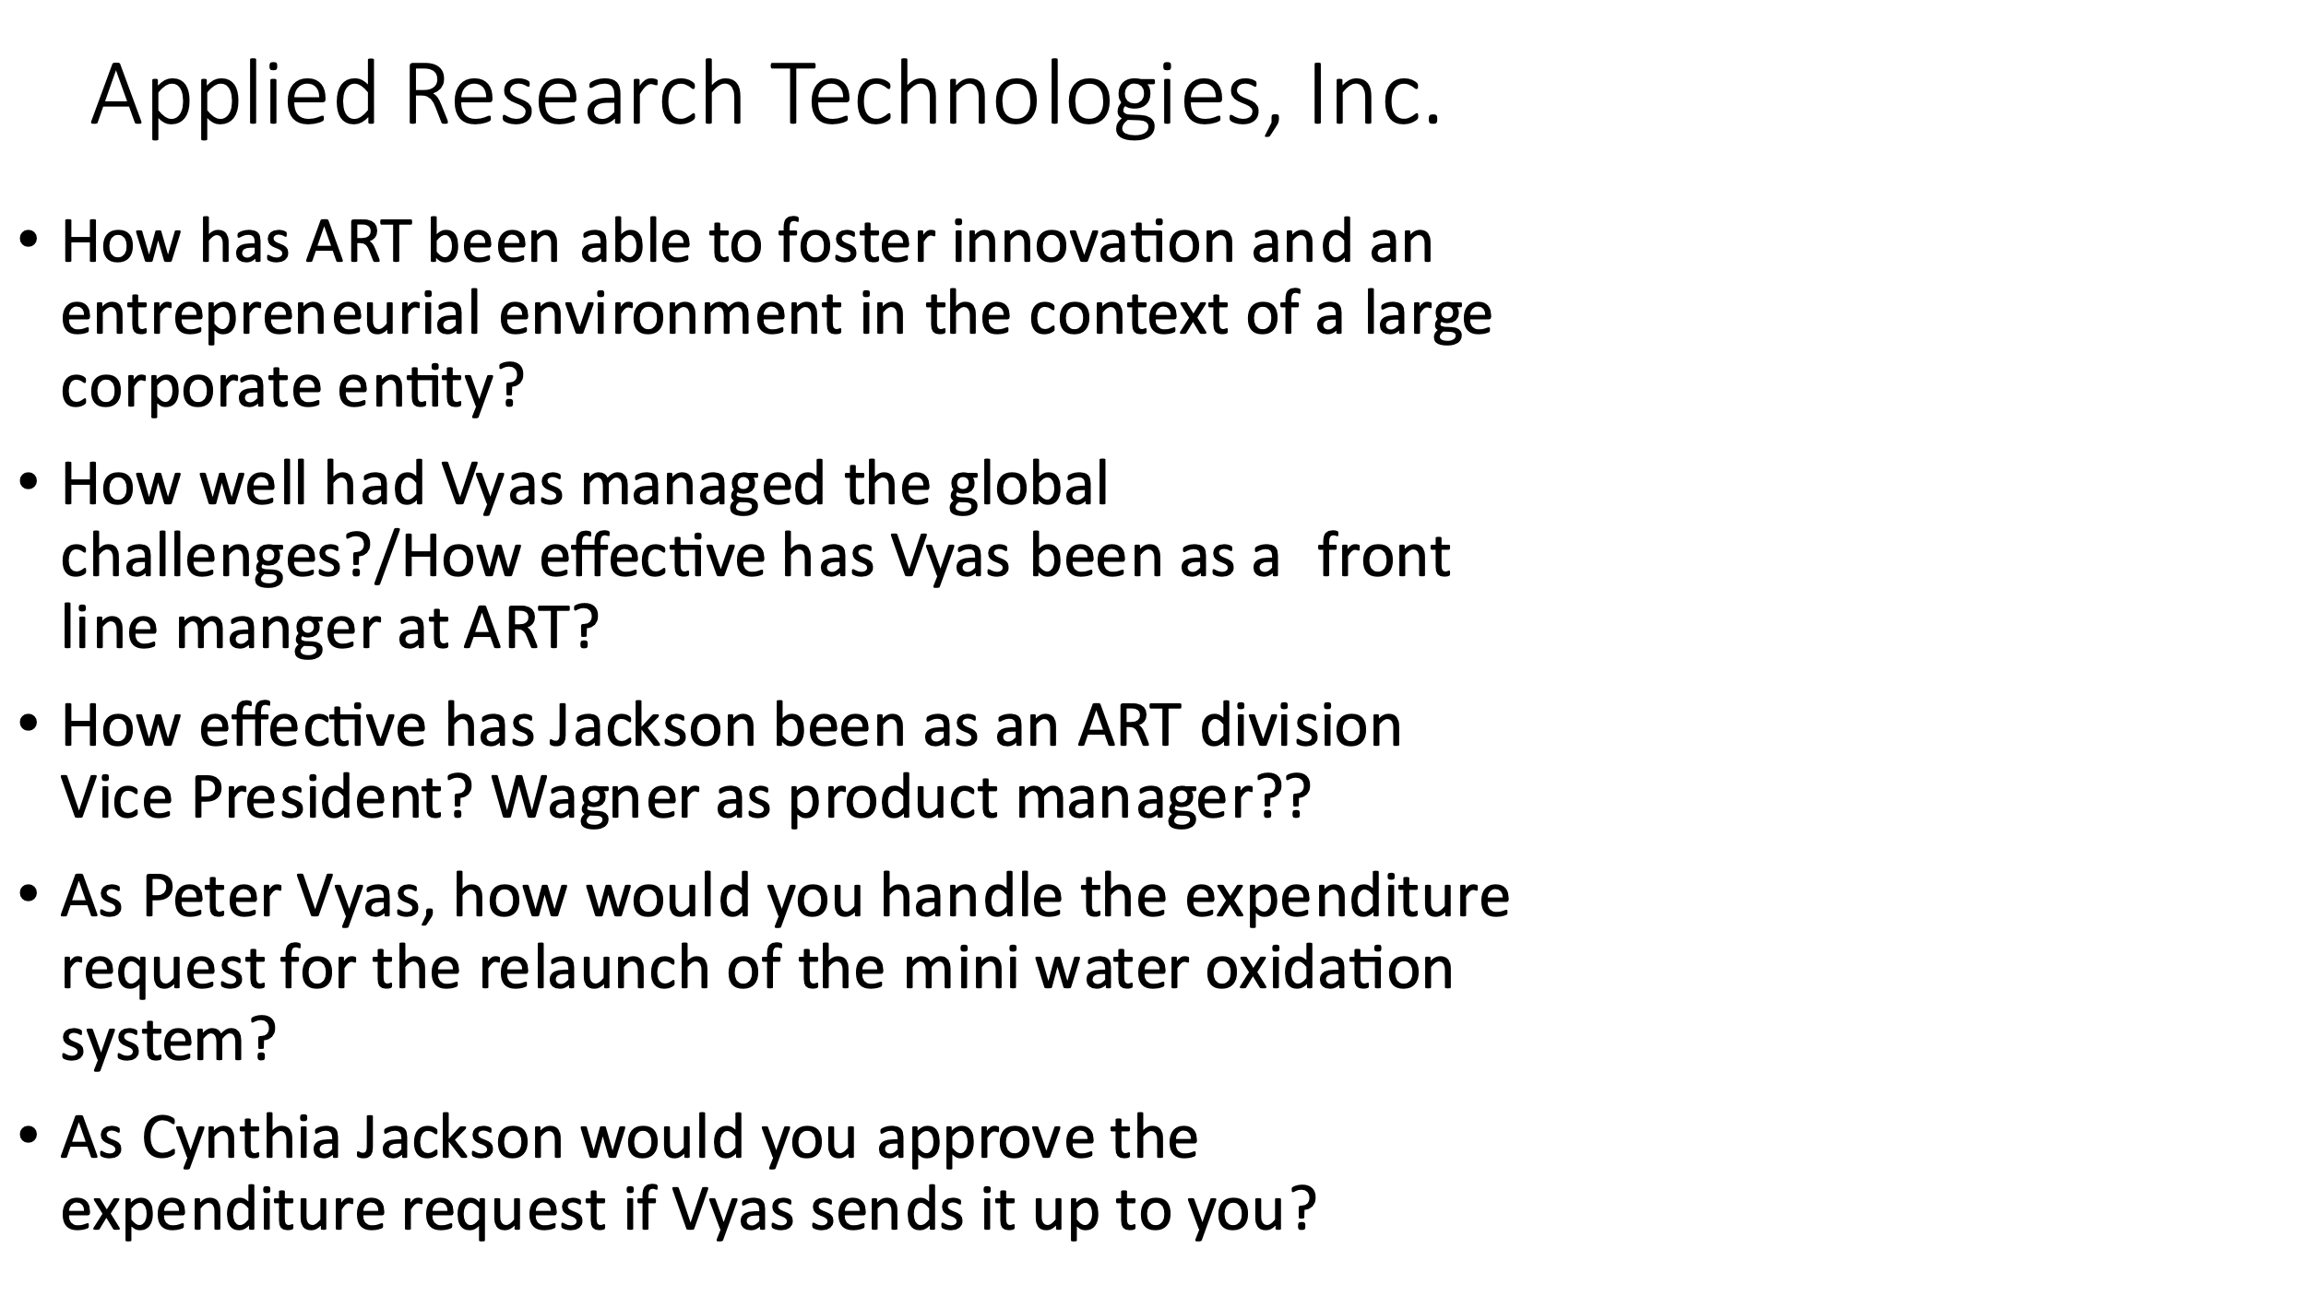

* **Case:** Tara Swan@ Nickelodeon Latin America – **HBS** **Course pack**

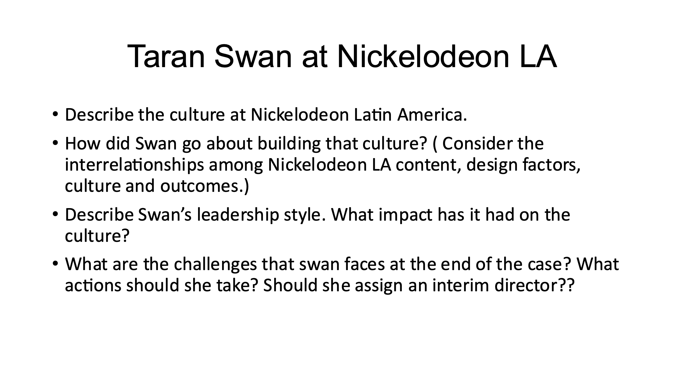

**Class 10 – November 9: Assignments – To be read before class**

* **Read Chapter 6**: Engaging in Cross-Border Collaboration: Managing Across Corporate Boundaries, pp. 477-493 (more Japan readings)
* **Case 6-2 Text**: Eli Lilly in India: Rethinking the Joint Venture Strategy, p. 376

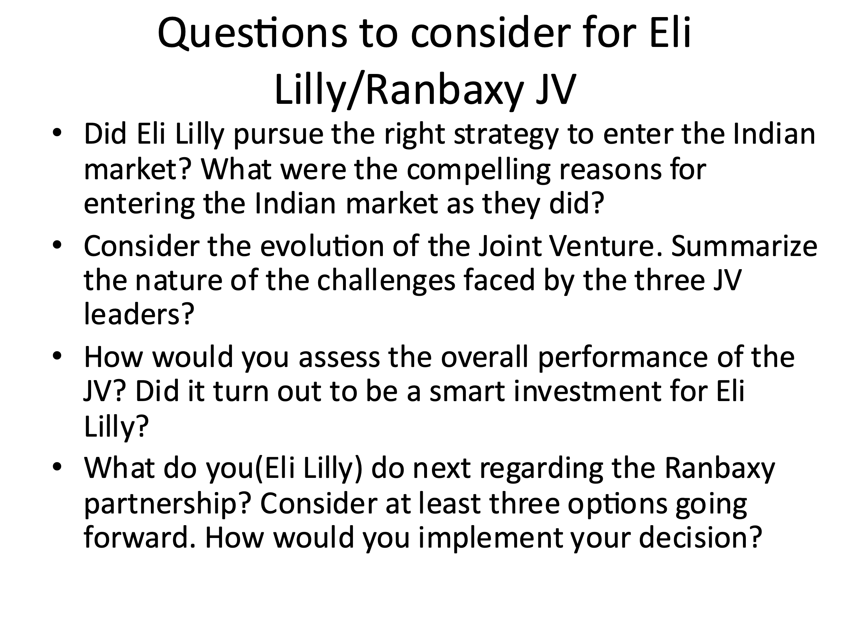

* **Case 6-3 Text**: **Case**: Apple and its Suppliers: Corporate Social Responsibility – HBS course pack

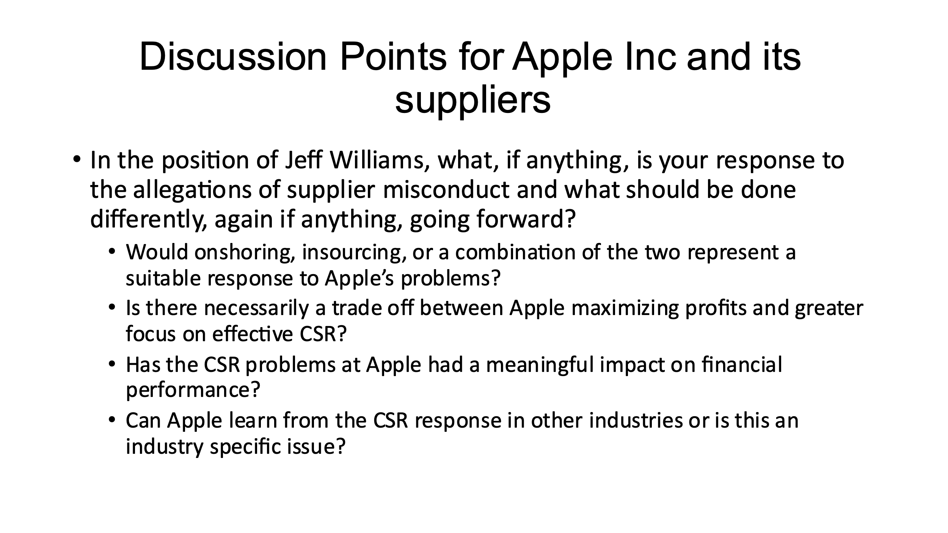

**Class 11 – November 16: Building Leadership Competencies:**

**Assignments to be read before class:**

* **Case 7-2, Text:** Unilever's Lifebuoy in India: Implementing the Sustainability Plan. p. 436

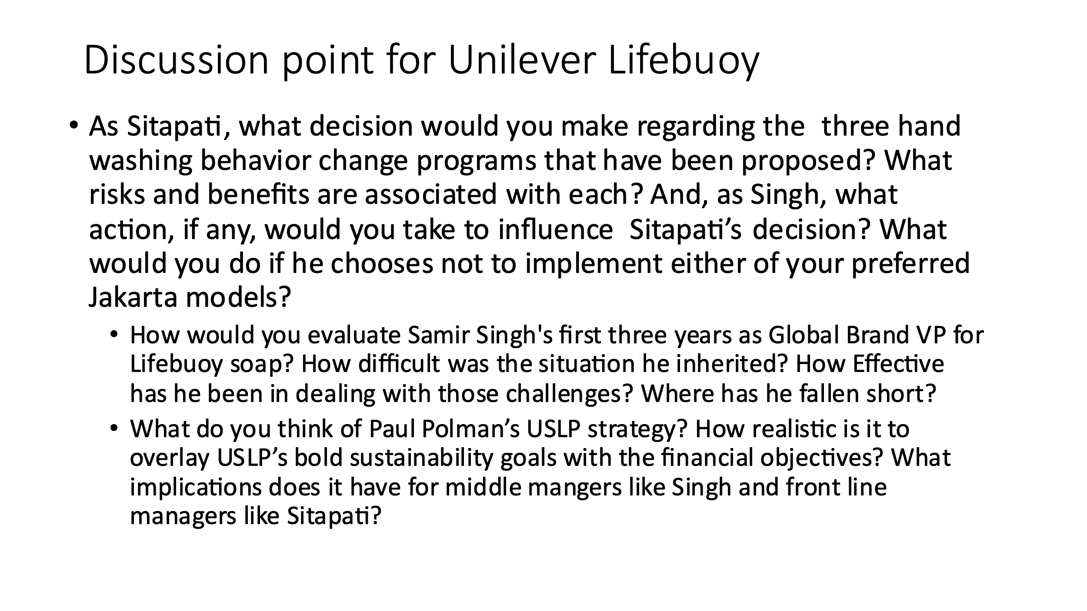

* **Case:** Cyberattack: The Maersk Global Supply-Chain Meltdown **– HBS Course pack**

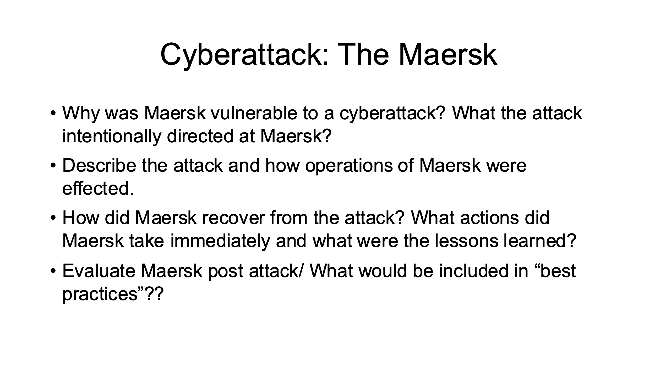

**Class 12 – November 30: Shaping the Transnational Future/Leading Change**

**Assignments to be read before class:**

* **Case:** Cynthia Carroll at Anglo American – HBS Course pack

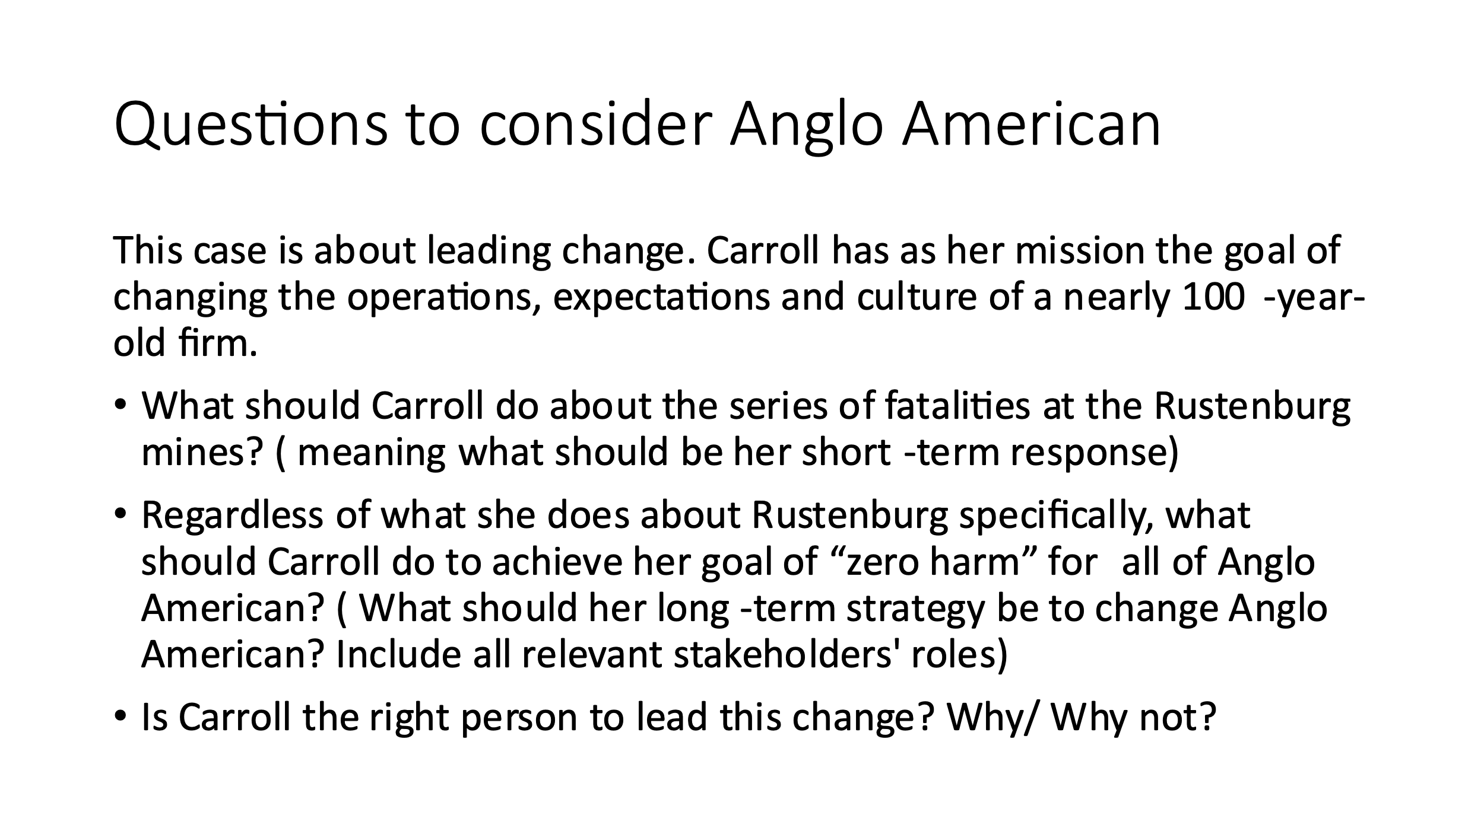

* **Case:** text 6-3: “ Amazon and the Future group: rethinking the Alliance Strategy” – HBS Course pack

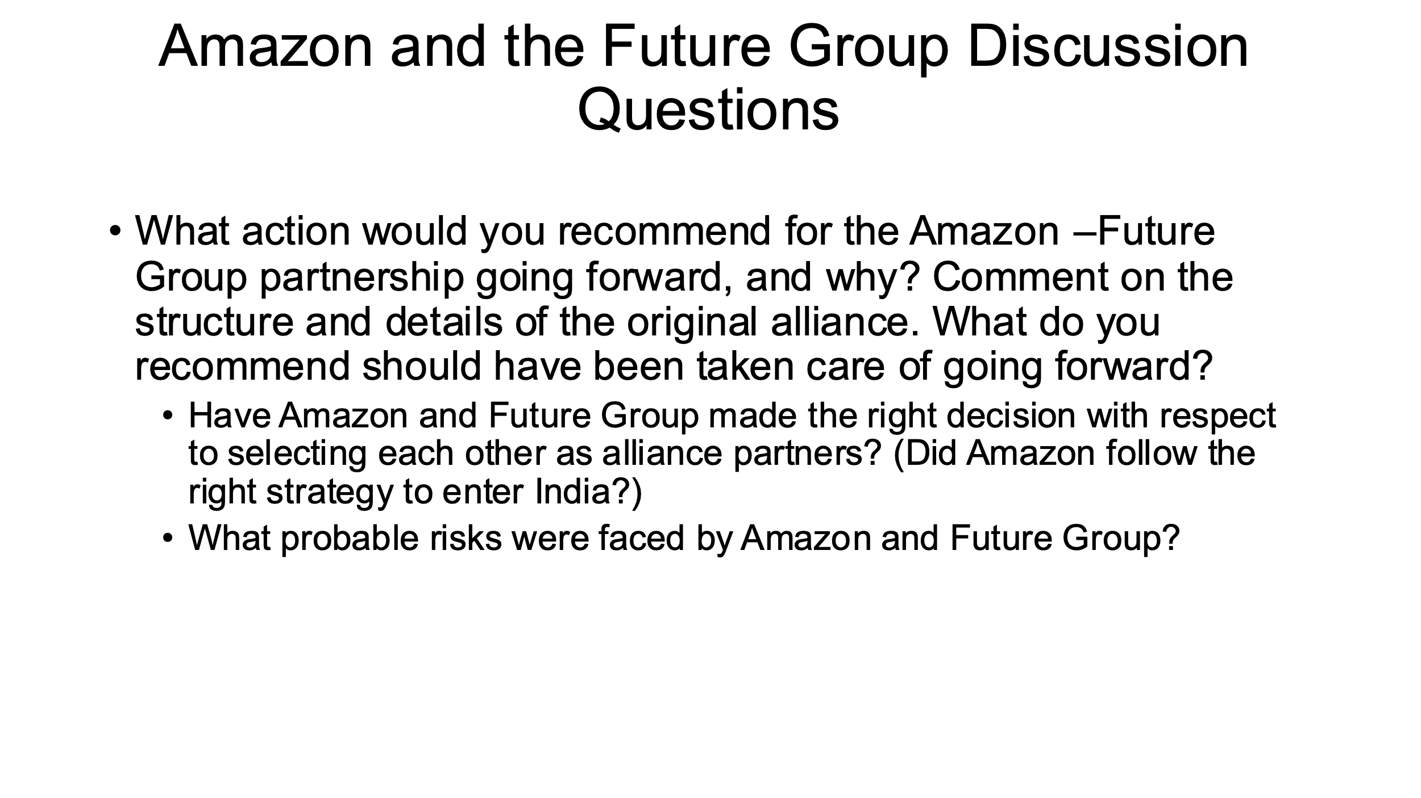

**Class 13 – December 7: Final Exam Day 1**

* **Final Exam** (Cases to be announced the week before)

**Class 14 – December 14: Final Exam Day 2:**

* **Final Exam** (Cases to be announced the week before)

**NOTES:**

The syllabus may be modified to better meet the needs of students and to achieve the learning outcomes.

The School of Professional Studies (SPS) and its faculty celebrate and are committed to inclusion, diversity, belonging, equity, and accessibility (IDBEA), and seek to embody the IDBEA values. The School of Professional Studies (SPS), its faculty, staff, and students are committed to creating a mutually respectful and safe environment (*from the* [*SPS IDBEA Committee*](https://www.sps.nyu.edu/homepage/about-us/idbea/about-idbea.html)).

**New York University School of Professional Studies Policies**

1. Policies - You are responsible for reading, understanding, and complying with [University Policies and Guidelines](http://www.nyu.edu/about/policies-guidelines-compliance.html), [NYU SPS Policies and Procedures](http://sps.nyu.edu/academics/academic-policies-and-procedures.html), and [Student Affairs and Reporting](https://www.nyu.edu/about/policies-guidelines-compliance/policies-and-guidelines/student-services.html).

2. Learning/Academic Accommodations - New York University is committed to providing equal educational opportunity and participation for students who disclose their dis/ability to the [Moses Center for Student Accessibility](https://www.nyu.edu/students/communities-and-groups/student-accessibility.html). If you are interested in applying for academic accommodations, contact the [Moses Center](https://www.nyu.edu/students/communities-and-groups/student-accessibility/academic.html) as early as possible in the semester. If you already receive accommodations through the Moses Center, request your accommodation letters through the [Moses Center Portal](https://www.nyu.edu/students/communities-and-groups/student-accessibility.html) as soon as possible ([mosescsa@nyu.edu](mailto:mosescsa@nyu.edu) | 212-998-4980).

3. Health and Wellness - To access the University's extensive health and mental health resources, contact the [NYU Wellness Exchange](https://www.nyu.edu/students/health-and-wellness/wellness-exchange.html). You can call its private hotline (212-443-9999), available 24 hours a day, seven days a week, to reach out to a professional who can help to address day-to-day challenges as well as other health-related concerns.

4. Student Support Resources - There are a range of resources at SPS and NYU to support your learning and professional growth. For a complete list of resources and services available to SPS students, visit the [NYU SPS Office of Student Affairs site](https://www.sps.nyu.edu/homepage/student-experience/resources-and-services.html).

5. Religious Observance - As a nonsectarian, inclusive institution, NYU policy permits members of any religious group to absent themselves from classes without penalty when required for compliance with their religious obligations. Refer to the [University Calendar Policy on Religious Holidays](https://www.nyu.edu/about/policies-guidelines-compliance/policies-and-guidelines/university-calendar-policy-on-religious-holidays.html) for the complete policy.

6. Academic Integrity and Plagiarism - You are expected to be honest and ethical in all academic work. Moreover, you are expected to demonstrate how what you have learned incorporates an understanding of the research and expertise of scholars and other appropriate experts; and thus recognizing others' published work or teachings—whether that of authors, lecturers, or one's peers—is a required practice in all academic projects.

Plagiarism involves borrowing or using information from other sources without proper and full credit. You are subject to disciplinary actions for the following offenses which include but are not limited to cheating, plagiarism, forgery or unauthorized use of documents, and false form of identification

[Turnitin](https://www.nyu.edu/servicelink/KB0018471), an originality detection service in NYU Brightspace, may be used in this course to check your work for plagiarism.

Read more about academic integrity policies at the NYU School of Professional Studies on the [Academic Policies for NYU SPS Students](https://www.sps.nyu.edu/homepage/student-experience/policies-and-procedures.html) page.

7. Use of Third-Party Tools - During this class, you may be required to use non-NYU apps/platforms/software as a part of course studies, and thus, will be required to agree to the “Terms of Use” (TOU) associated with such apps/platforms/software.

These services may require you to create an account but you can use a pseudonym (which may not identify you to the public community, but which may still identify you by IP address to the company and companies with whom it shares data).

You should carefully read those terms of use regarding the impact on your privacy rights and intellectual property rights. If you have any questions regarding those terms of use or the impact on the class, you are encouraged to ask the instructor prior to the add/drop deadline.